Ocean University of China

Report on Human Computer Interface

Programming 3.1.1

### [Use D3.js to draw basic chart](https://wlkc.ouc.edu.cn/webapps/blackboard/content/launchLink.jsp?course_id=_12991_1&content_id=_527830_1&mode=view)**s**

Name：**Praise Mlambo**

**BK2018024**

Instructor：

Time of Submission：

**Experiment report:**

1. The experiment was, in my understanding, about getting familiar with more of the methods for visualizing data in d3.

**Steps:**

1. The first part of the experiment, reading the population data from

 population_total.csv from Gapminder’s public data set.

**~Filtering countries with population less than 100,000,000:**  
 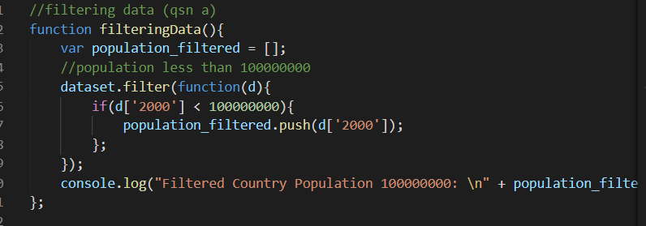

I made a custom function to accomplish this task , then output the results on the console.

**~Sorting the data of 2000 in descending order:**

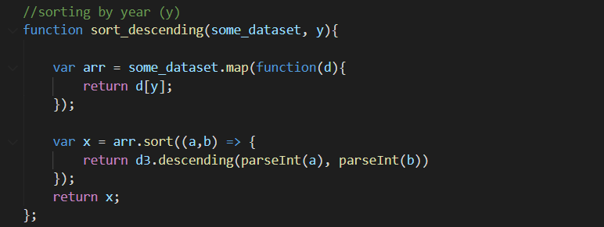

The function is versatile, we can choose any other year if we decide we don’t just want to sort the data of the year 2000 anymore. Good for future use, against different scenarios.

**~Sorting data for each country in 2000**

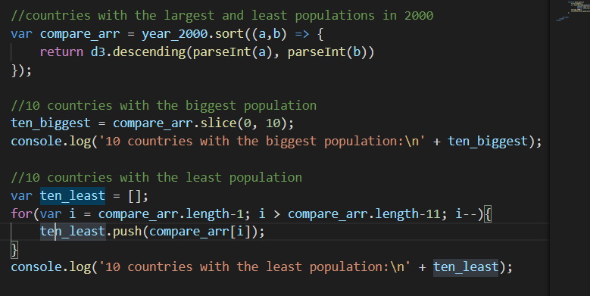

**~Statistical calculations:**

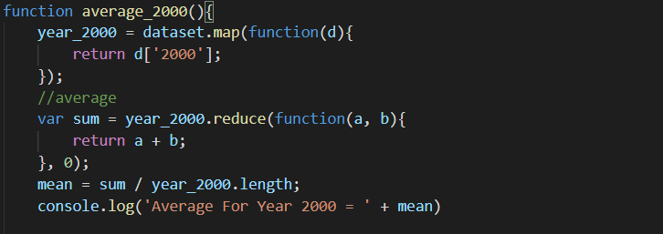

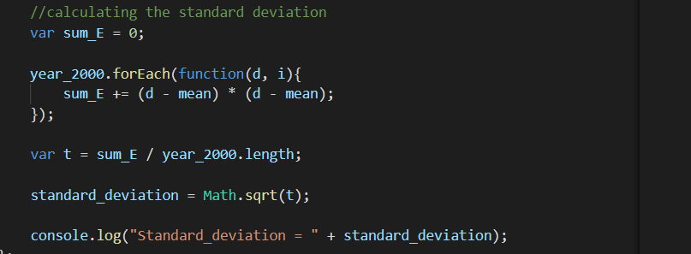

**~Drawing a histogram:**

I completed this part. Later decided to add a little slider to the chart that changes the height if the bars with the change in the years

Resulting graph:

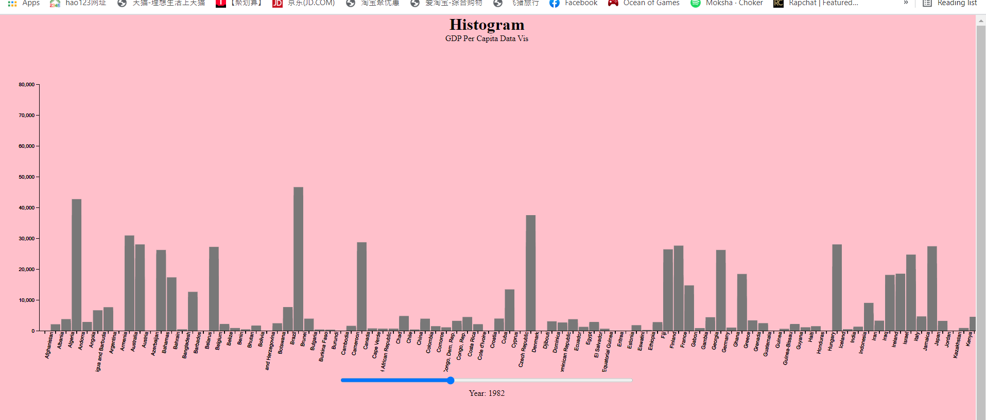

**~The points on top of the rectangles on the histogram:**

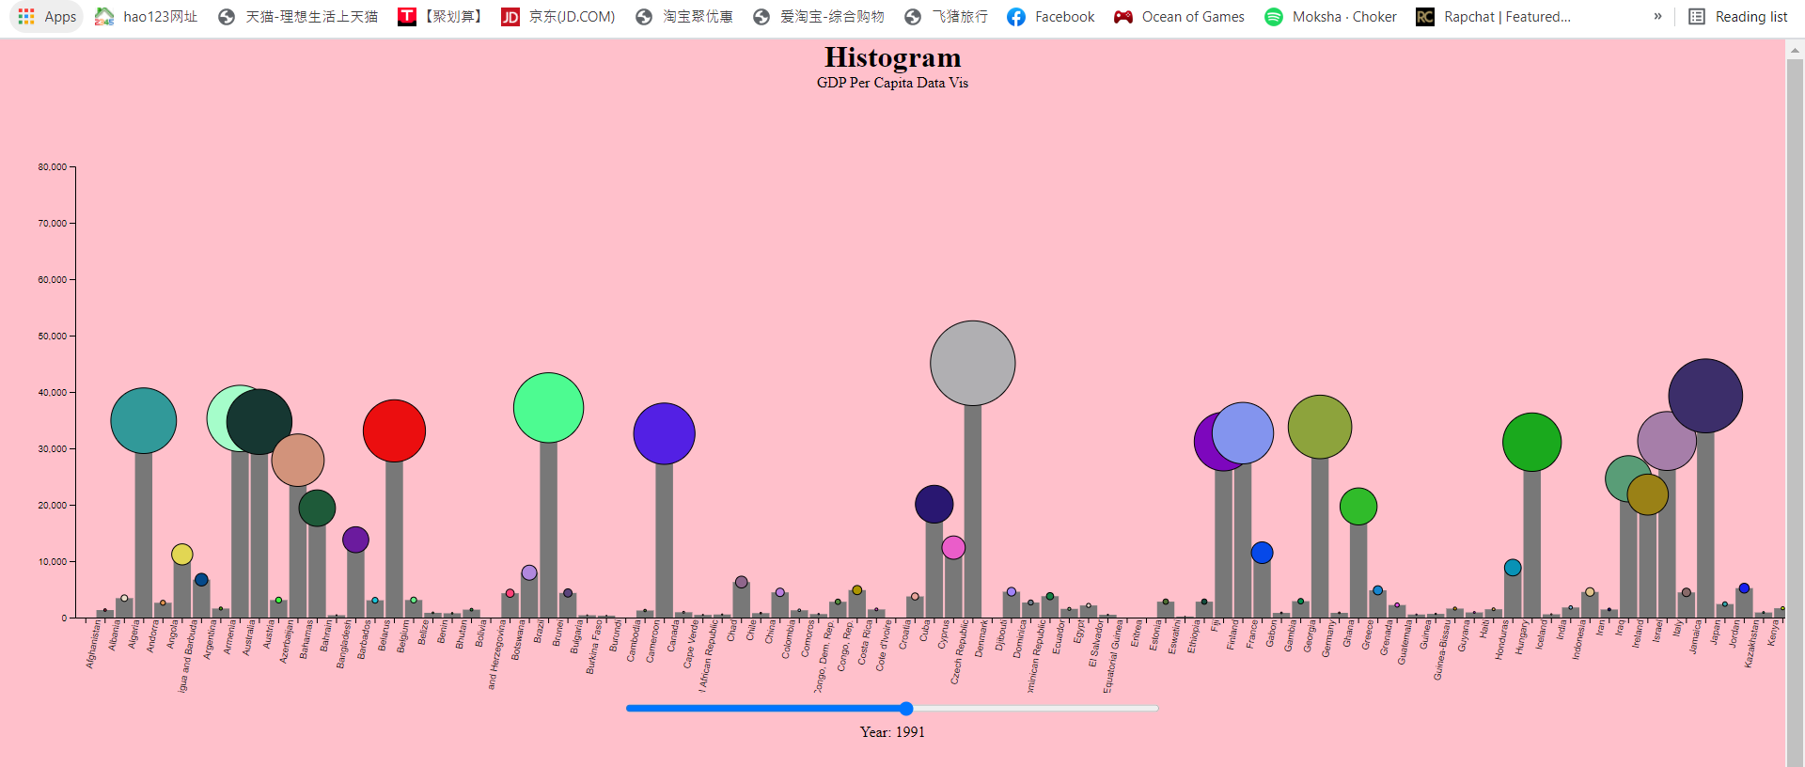

For this part, I just appended circles at the top of the rectanles in the already existing histogram graph.

**~Scatter plot**

This part required linking different files, I archieved this as shown below:

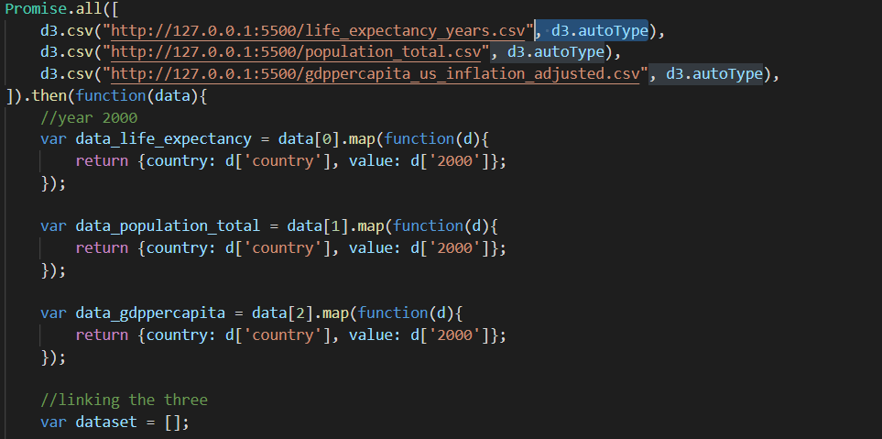

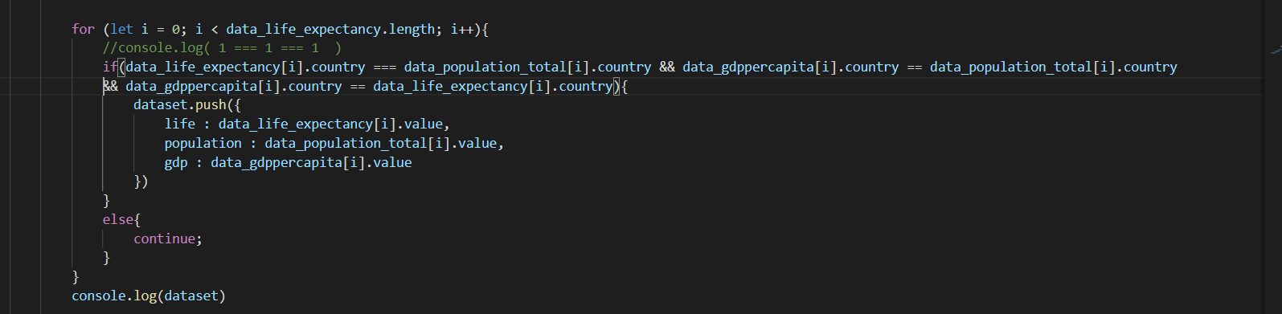

~The resulting scatter plot came out as shown below:

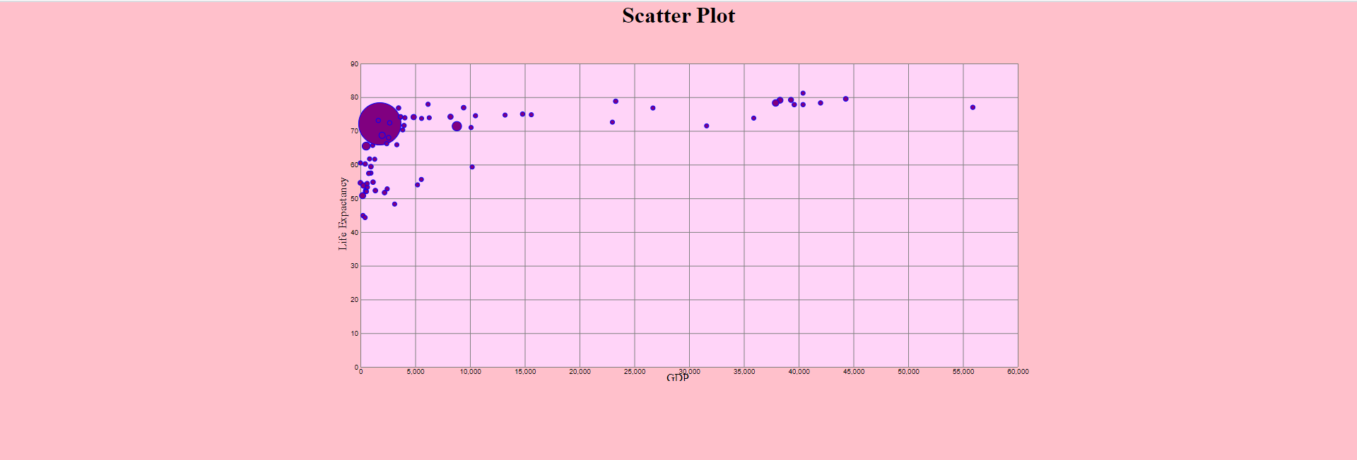

**~Other charts**

**Pie Chart and Doughnut Chart:**

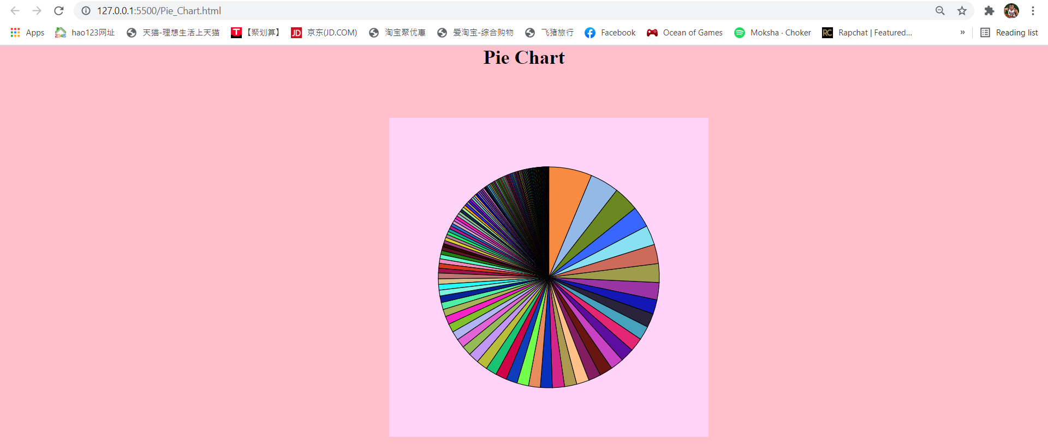

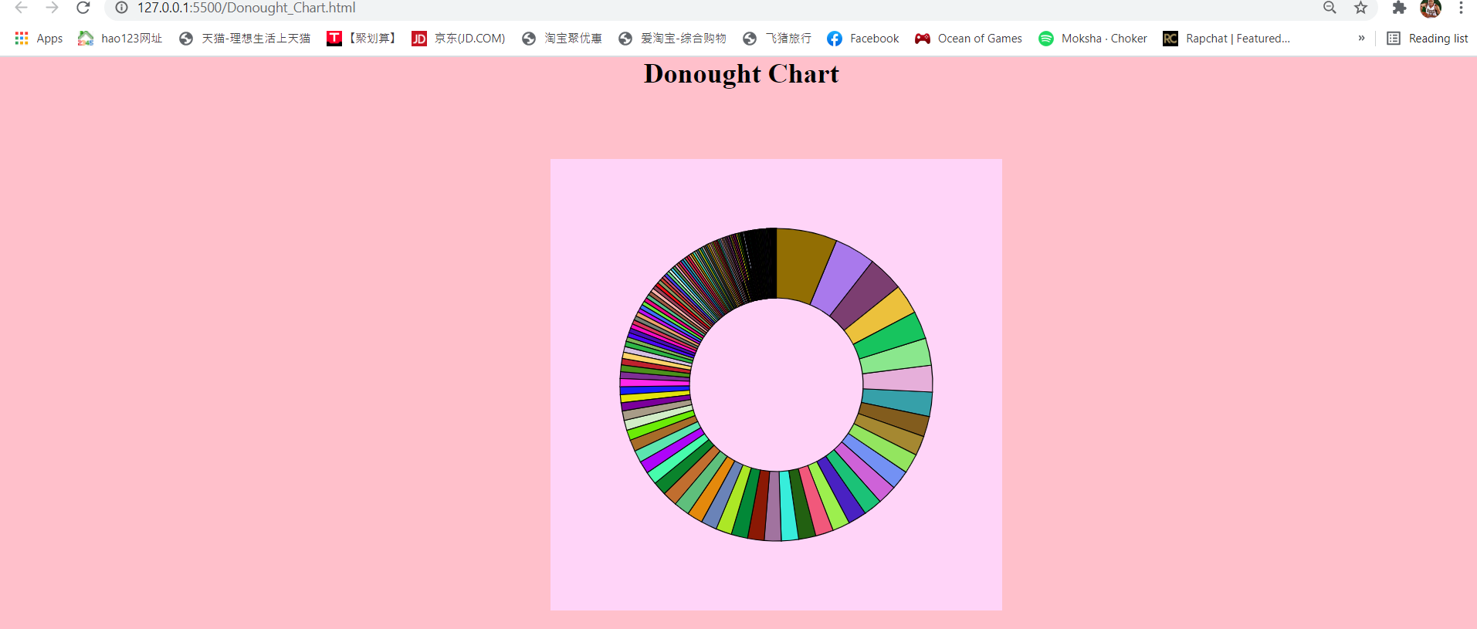

Since these two charts are are almost the same, the only difference was changing the innerRadius for the donut chart. For the pie chart it was zero



**~Symbol Map**

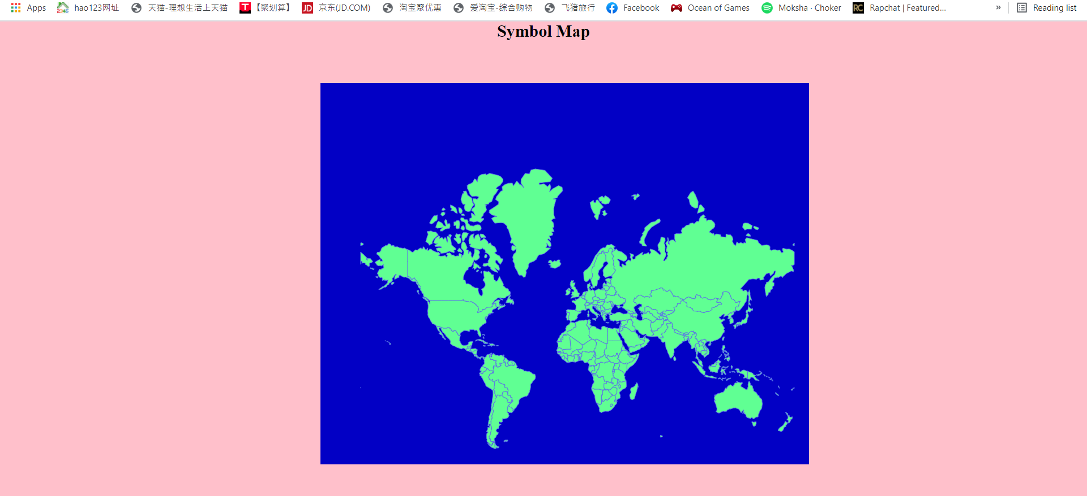

**~Complex Charts**

For this part I chose the circular bar plot. I the example on [www.d3-graph-gallery.com](http://www.d3-graph-gallery.com)

The chart finally looked as shown below:  
 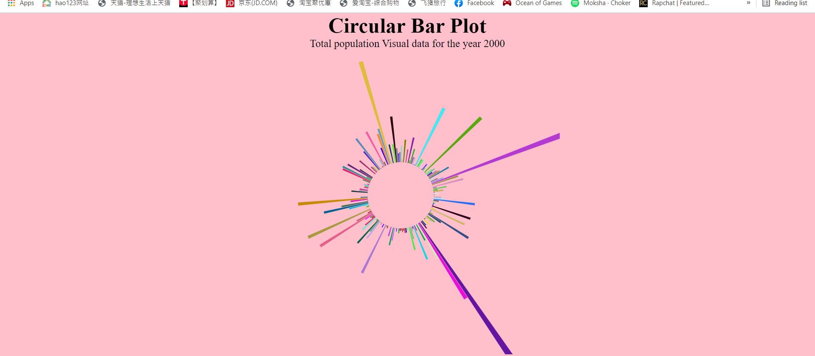

For the bars, I just put different colors because it looks nice.